Supplementary Materials

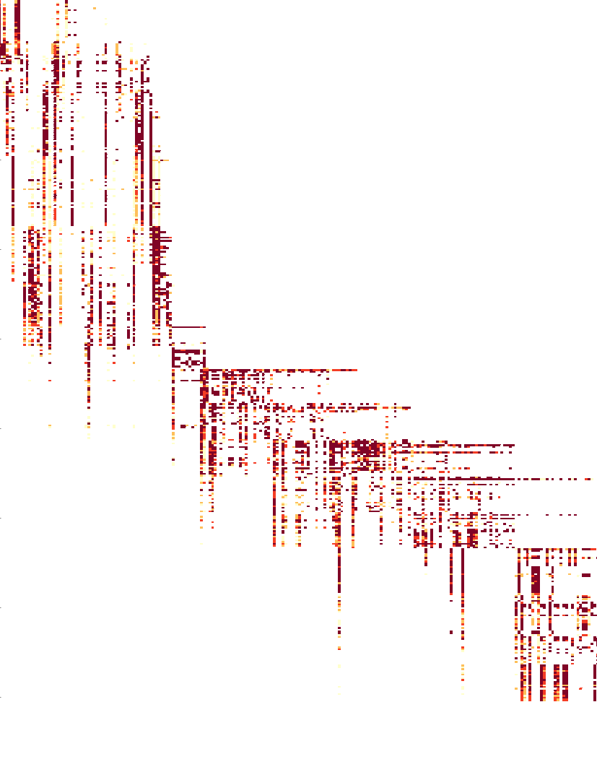**Figure S1. Heatmap of the A/H3N2 hemagglutination inhibition assay titer measurements.** Darker color intensity represents higher titer and white represents missing data. Each cell represents the titer between a virus (row) and a serum (column). Viruses are sorted by year from 1968 (first row) to 2011 (last row). Serum is also sorted by year from 1968 (leftmost column) to 2011 (rightmost column).

Macintosh HD:Users:charles:Documents:research:antigenic:GenoPheno:antigenic-clustering:manuscript:figures:lineart:swapIandMuNeighbor.pdf

**Figure S2. Schematic diagram of Proposal 4 - Swap Ii and μi with a neighbor**.

In this phylogeny, the brown active node is chosen to perform the swap-with-neighbor proposal. In this case, with a neighborhood step-size of 2, the set of candidates consist of all the nodes within the green neighborhood.

Macintosh HD:Users:charles:Documents:research:antigenic:GenoPheno:antigenic-clustering:manuscript:figures:lineart:walkAndBalance.pdf

**Figure S3. Proposal 5 - Performs a random walk on an active μi and balance other active μj.**

In this antigenic map, μ1 is now changed by δ, which causes the antigenic location of viruses in the brown cluster to change. To retain the absolute location of viruses in other clusters, μ2 and μ3 are adjusted by subtracting δ .

Macintosh HD:Users:charles:Documents:research:antigenic:GenoPheno:antigenic-clustering:manuscript:figures:lineart:swapAndFlipNeighbor.pdf

**Figure S4. The candidate of nodes to be flipped in Proposal 7 - Swap with a neighbor and flip another neighbor.** In the second operation that flips the indicator status of another neighbor, the list of nodes to consider include neighbors (green neighborhood) from the original pivot node (green node) and the neighbors (blue neighborhood) of the newly chosen node (diamond).

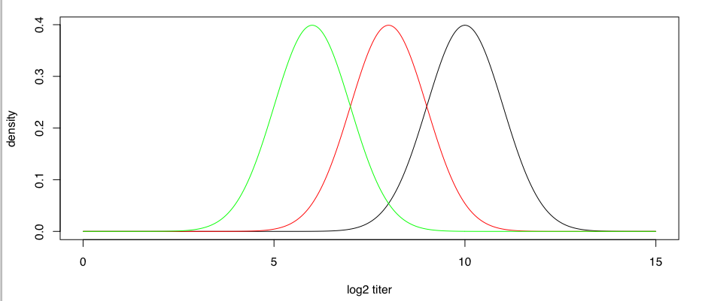

**Figure S5. Simulation of log2 HI titer consists of measurement noises.** For a virus i and a reference virus for serum j that belongs to the same antigenic cluster, the distribution of measurements follows *N*(10, σ2). For each antigenic transition between the two viruses, the mean measurement decreases by 2 units.

|  |
| --- |
| Macintosh HD:Users:charles:Documents:research:antigenic:GenoPheno:driver:clustering:analysisManuscript7-31-2015:H3N2:mu:mu-Euclidean-mds0_1.pdf |
| Macintosh HD:Users:charles:Documents:research:antigenic:GenoPheno:driver:clustering:analysisManuscript7-31-2015:H1N1:mu:mu-Euclidean-mds0_3.pdf |

**Figure S6. Histogram of the Euclidean distance of μ from the parent clusters for the A/H3N2 analysis with κ=0.1 [top] and for the A/H1N1 analysis with κ = 0.3 [bottom]**.

/Users/charles/Documents/research/antigenic/GenoPheno/driver/clustering/analysisManuscript7-31-2015/H3N2/mu/mu-Euclidean-mds0\_1.pdf

/Users/charles/Documents/research/antigenic/GenoPheno/driver/clustering/analysisManuscript7-31-2015/H1N1/mu/mu-Euclidean-mds0\_3.pdf

**Sensitivity Analyses**

|  |
| --- |
| Macintosh HD:Users:charles:Library:Group Containers:UBF8T346G9.Office:msoclip:clip_image001.png |
| Macintosh HD:Users:charles:Library:Group Containers:UBF8T346G9.Office:msoclip:clip_image002.png |

**Figure S7. Distribution of Gelman-Rubin statistics of the estimated pi from the 10 replicates for A/H1N1 at κ = 0.1 (top) and at 0.3 (bottom) .**

NEED TO UPDATE, NOW HAVE 10 replicates

/Users/charles/Documents/research/antigenic/GenoPheno/driver/clustering/analysisManuscript2-12-2015/H1N1/concordance/GelmanRubinStat\_2runs\_mds0\_1\_with\_ponGT0\_1\_in\_rep1.png

/Users/charles/Documents/research/antigenic/GenoPheno/driver/clustering/analysisManuscript2-12-2015/H1N1/concordance/GelmanRubinStat\_2runs\_mds0\_3\_with\_ponGT0\_1\_in\_rep1.png

|  |
| --- |
| Macintosh HD:Users:charles:Library:Group Containers:UBF8T346G9.Office:msoclip:clip_image003.png |
| Macintosh HD:Users:charles:Library:Group Containers:UBF8T346G9.Office:msoclip:clip_image004.png |

**Figure S8. Scatterplot of the estimated pi comparing replicate 1 and 2 for A/H1N1 at κ= 0.1 (R2 = #) and at 0.3 (R2 = #).**

/Users/charles/Documents/research/antigenic/GenoPheno/driver/clustering/analysisManuscript2-12-2015/H1N1/concordance/H1N1-C3b-mds0\_1-concordance.eps

/Users/charles/Documents/research/antigenic/GenoPheno/driver/clustering/analysisManuscript2-12-2015/H1N1/concordance/H1N1-C3b-mds0\_1Vs0\_3-concordance.eps

**I could use a table to display across 10 replicates..**

|  |  |
| --- | --- |
| Macintosh HD:Users:charles:Library:Group Containers:UBF8T346G9.Office:msoclip:clip_image008.png  **κ = 0.05** | Macintosh HD:Users:charles:Library:Group Containers:UBF8T346G9.Office:msoclip:clip_image007.png  **κ = 0.1** |
| Macintosh HD:Users:charles:Library:Group Containers:UBF8T346G9.Office:msoclip:clip_image009.png  **κ = 0.15** |  |

**Figure S9. Distribution of Gelman-Rubin statistics of the estimated pi from the 10 replicates for A/H3N2 at different κ.**

**NEED TO UPDATE, NOW HAVE 10 replicates**

/Users/charles/Documents/research/antigenic/GenoPheno/driver/clustering/analysisManuscript2-12-2015/H3N2/concordance/GelmanRubinStat\_mds0\_1\_with\_ponGT0\_1\_in\_rep1.png

 /Users/charles/Documents/research/antigenic/GenoPheno/driver/clustering/analysisManuscript2-12-2015/H3N2/concordance/GelmanRubinStat\_mds0\_05\_with\_ponGT0\_1\_in\_rep1.png

 /Users/charles/Documents/research/antigenic/GenoPheno/driver/clustering/analysisManuscript2-12-2015/H3N2/concordance/GelmanRubinStat\_mds0\_15\_with\_ponGT0\_1\_in\_rep1.png

|  |  |
| --- | --- |
| Macintosh HD:Users:charles:Library:Group Containers:UBF8T346G9.Office:msoclip:clip_image010.png  **κ= 0.05** | Macintosh HD:Users:charles:Library:Group Containers:UBF8T346G9.Office:msoclip:clip_image011.png  **κ= 0.1** |
| Macintosh HD:Users:charles:Library:Group Containers:UBF8T346G9.Office:msoclip:clip_image012.png  **κ= 0.15** |  |

**Figure S10. Scatterplot of the estimated pi comparing replicate 1 and 2 for A/H1N1 at κ= 0.05 (R2 = #), 0.1 (R2 = #), and at 0.15 (R2 = #).**

/Users/charles/Documents/research/antigenic/GenoPheno/driver/clustering/analysisManuscript2-12-2015/H3N2/concordance/H3N2-C3b-mds0\_05-concordance.eps

/Users/charles/Documents/research/antigenic/GenoPheno/driver/clustering/analysisManuscript2-12-2015/H3N2/concordance/H3N2-C3b-mds0\_1-concordance.eps

/Users/charles/Documents/research/antigenic/GenoPheno/driver/clustering/analysisManuscript2-12-2015/H3N2/concordance/H3N2-C3b-mds0\_15-concordance.eps

**NEED TO UPDATE**

Tracer plots:

“Diagnostic plots obtained from Tracer (Figure SX-Y) collectively suggest that other parameters also mixed adequately.”

|  |  |
| --- | --- |
| Macintosh HD:Users:charles:Library:Group Containers:UBF8T346G9.Office:msoclip:clip_image005.png1 | Macintosh HD:Users:charles:Library:Group Containers:UBF8T346G9.Office:msoclip:clip_image006.png2 |
| Macintosh HD:Users:charles:Dropbox:antigenic-clustering:analysisManuscript2-12-2015:H1N1:heatmap:H1N1-C3b-mds0_1_vsS4-ordered.png3 | Macintosh HD:Users:charles:Dropbox:antigenic-clustering:analysisManuscript2-12-2015:H1N1:heatmap:H1N1-C3b-mds0_1_vsS5-ordered.png4 |
| Macintosh HD:Users:charles:Dropbox:antigenic-clustering:analysisManuscript2-12-2015:H1N1:heatmap:H1N1-C3b-mds0_1_vsS6-ordered.png5 |  |

**Figure S11. Comparing the clustering patter between the MCC tree (upper triangle) and sampled tree 1-5 (lower triangle) for A/H1N1.**

/Users/charles/Documents/research/antigenic/GenoPheno/driver/clustering/analysisManuscript1-21-2015/H1N1/heatmap/H1N1-C3b-**mds0\_1**\_vsS2-ordered.png

Users/charles/Documents/research/antigenic/GenoPheno/driver/clustering/analysisManuscript1-21-2015/H1N1/heatmap/H1N1-C3b-mds0\_1\_vsS3-ordered.png

|  |  |
| --- | --- |
| achine generated alternative text: 」 幸 明 必 。 ー  0  ・ 厰 、 当  010  開 9  7 〕 8  8 村 2 〕 8  . 司 嗣 当 圷 当 一 一 ~ ′ 当 司 社 小 一 当 凱  38 ′ 2005  : 了 省 、  2003  爿 当 い 司 爿 当 司 司 当 当 当 当 当  ・ 事 い 環 、 ギ 当 ・  ~ 旧 」 れ 物 温 彗 れ 0 囃 弭 眦 ~ い 呶 ( 轟 耻 囃 れ 上 、  崕 箋 瞻 區 幇 を 。 。 糴 ) ~ 黐 爾  ル に ー  ・ ぶ 磆 ・  当 4 鰲 」 キ ト き を - : ド  パ こ : - 墾 ま ぎ 隴  : 嚶 巻  : = を 当 い  ょ 蠧 : 尊 鼇 噐 鑿 駲 : 蕊  ま ま ~ び  4!MS,'V  - 山 pe イ | Macintosh HD:Users:charles:Dropbox:antigenic-clustering:analysisManuscript2-12-2015:H3N2:heatmap:H3N2-C3b-mds0_1_vsS3-ordered.png |
| Macintosh HD:Users:charles:Dropbox:antigenic-clustering:analysisManuscript2-12-2015:H3N2:heatmap:H3N2-C3b-mds0_1_vsS4-ordered.png | Macintosh HD:Users:charles:Dropbox:antigenic-clustering:analysisManuscript2-12-2015:H3N2:heatmap:H3N2-C3b-mds0_1__vsS5-ordered.png |
| Macintosh HD:Users:charles:Dropbox:antigenic-clustering:analysisManuscript2-12-2015:H3N2:heatmap:H3N2-C3b-mds0_1__vsS6-ordered.png |  |

**Figure S12. Comparing the clustering patter between the MCC tree (upper triangle) and sampled tree 1-5 (lower triangle) for A/H3N2.**

/Users/charles/Documents/research/antigenic/GenoPheno/antigenic-clustering/summarizedResults/H3N2/heatmap/H3N2-C3b-mds0\_1\_vsS2-ordered.png